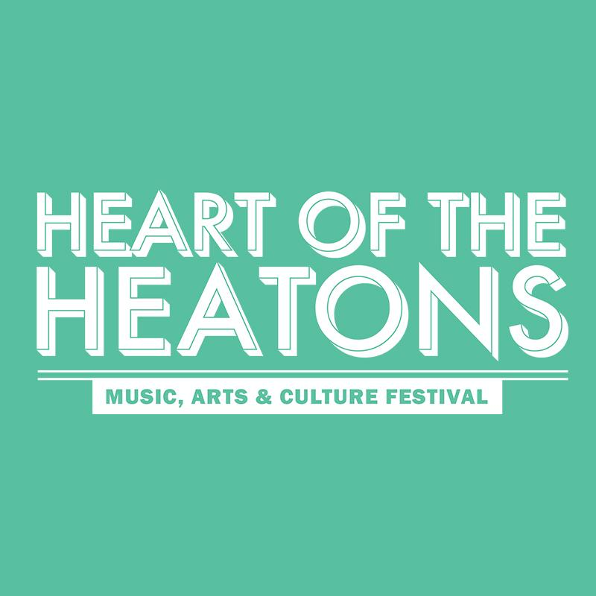
ADULT: PHOTOGRAPHY COMPETITION ENTRY FORM

Terms and conditions:
- One entry per person
- One winner and one runner up for each age category: 16- 24years, Over 25 years and Over 50 years. All entries must be on the theme of connection.
- No cost to enter
- Judges’ decision is final
- Prizes include: winner to receive a framed copy of their entry and awards trophy; shortlisted photographs to be displayed in the Heatons during the festival; suitable entries to be published on the Heart of the Heatons flickr account; all entrants to receive a participatory certificate. Other prizes to be announced. No cash prize alternative available and prizes may change at the organisers’ discretion
- Entrant must submit their own work and not that of another person
- Entrant must also submit a signed declaration accepting terms and conditions
- Publishing rights automatically granted by each entrant for the festival organisers to publish photography entries as appropriate
- You must obtain all permission and releases from all persons (or the parent/guardian of any young persons) appearing in any photo/still images
- Everyone appearing in this photograph under 18 has been given consent to be in this photograph by their Parent / Guardian and has given consent for this photograph to be submitted to Heart of the Heatons festival competition
- By providing your email address and entering this competition you agree to receive relevant email communications from Heart of the Heatons including news, events, offers and competitions
- All data will be retained securely and will not be shared with any third-party entities
- Winners and runner up names announced during Heart of the Heatons 2019

Competition entry deadline: Friday 13th September 2019. Please submit your Photograph as a PNG or JPEG file. For files under 10MB please send directly to the Heart of the Heatons email. For files over 10MB please send to us via a file transfer site like wetransfer.com . Questions, submissions and signed form to heartoftheheatons@gmail.com THANK YOU!

Entry Information:
Competition: | Photography
Image title:

In less than 100 words, please tell us a bit about your image and how it relates to the theme ‘connection’
Name: | ……………………………………….
Age: | ……………………………………….
Contact no.  (to contact you in the event of a winning entry) | ……………………………………….
Email: | ……………………………………….
Signed by entrant: | ……………………………………….

Questions, submissions and signed form to heartoftheheatons@gmail.com THANK YOU!

